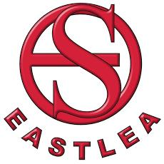Eastlea Community School
CONSISTENCY FRAMEWORK

Consistency In Lessons
Staff should always follow the framework to ensure that all students know exactly what is required of them. Senior staff will regularly visit classes to support the implementation of this framework. Students are in school to learn and should follow the framework to ensure maximum learning and progress.

Arriving at the lesson:

Start of lesson / register / lateness:

Answering Questions / Rules for talk:

Students out of seats and out of class:

End of lesson:

Eastlea Community School
CONSISTENCY FRAMEWORK

Consistency Around The School
Manners and conduct:

Movement around the school:

Break and lunch times:

Respect for yourselves and our environment:

Mobile phones and valuables:

Eastlea Community School
CONSISTENCY FRAMEWORK

Uniform and Community Clarification
Uniform:

Community:

