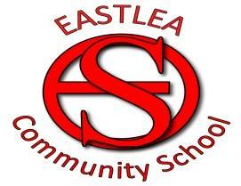

CHARGING POLICY

CHARGING POLICY

- Introduction

  - All activities including materials and transport (except detailed in Section) which take place wholly or mainly within school hours for the benefit of registered school students shall be free. Parents\carers may be asked for voluntary contribution to cover the costs of such activities as educational visits.

1.2 a) Where less than 50% of the number of hours spent on non-residential activity takes place outside school hours, then that activity shall be deemed to take place during school hours.

- In the case of an activity involving an overnight stay, it shall be deemed
to take place outside school hours if more than 50% of the number of half-day sessions is spent away from school. A half-day means any period of 12 hours ending with noon or midnight.

- Charges to be applied

Charges will be made in the following circumstances only:

To cover costs of providing ‘optional extras’. These are defined as activities which take place ‘wholly or mainly outside school hours’ and:
- are NOT designed to fulfil any requirements specified in the syllabus for a prescribed public examination; OR
- are NOT related to fulfilment of the National Curriculum or religious education requirements laid down in Section 10 of the Education Reform Act 1988.

Optional extras could include, therefore:

- Lunchtime and after-school clubs
- Weekend sporting activities
- Residential trips outside school hours
- Evening theatre visits
- After school classes and other activities

Parents\guardians must choose to allow their children to take part in optional extras, and must agree in advance to meet any charges. Any charges made must not exceed the cost of the provision.

